A COMMUNITY SERVICE PROJECT REPORT

ON THE IMPACT OF SMART PHONES AND MOBILE DEVOCES ON HUMAN HEALTH

AND LIFE BY

|  |  |  |
| --- | --- | --- |
| 1 | P.JATHIN | 20B81A05D0 |
| 2 | P.HARISH | 20B81A05D3 |
| 3 | P.ANJANEYULU | 20B81A05D3 |
| 4 |  | 20B81A05D4 |
| 5 |  | 20B81A05D5 |
| 6 |  | 20B81A05D6 |
| 7 |  | 20B81A05D7 |
| 8 |  | 20B81A05D8 |
| 9 |  | 20B81A05D9 |
| 10 |  | 20B81A05E0 |
| 11 |  | 20B81A05E1 |
| 12 |  | 20B81A05E2 |
| 13 |  | 20B81A05E3 |
| 14 |  | 20B81A05E4 |
| 15 |  | 20B81A05E5 |
| 16 |  | 20B81A05E6 |
| 17 |  | 20B81A05E7 |
| 18 |  | 20B81A05E8 |
| 19 |  | 20B81A05E8 |
| 20 |  | 20B81A05F0 |
| 21 |  | 20B81A05F1 |

In partially fulfilment for the award of 2nd degree of Bachelor **of Technology**

Under the guidance of **Smt.S.S.L. SABARI KUMARI**

**Department of Computer Science and Engineering**

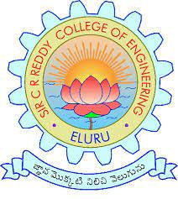

**Department of Computer Science and Engineering**

**SIR C.R. REDDY COLLEGE OF ENGINEERING**

**(Affiliated to Jawaharlal Nehru Technological University, Kakinada)**